Topic: Reducing Our Carbon Footprint
Student Version

Summary:
You will understand the importance of safeguarding the ecological security of Hong Kong and our country, and how this can be achieved through reducing our carbon footprint.
- Participating in jigsaw reading and a group discussion

- Viewing the video “Electric Vehicles You’ll Want to Know About” to understand the latest developments of electric vehicles (EVs) in China

- Reading a fact sheet to have a better understanding of the strategies adopted to promote EVs in the Mainland and Hong Kong

- Writing an article to promote the use of EVs to safeguard the ecological security of Hong Kong

Part 1 – Warm-up Activity
A) Fun facts about vehicles
Answer the following questions with your own knowledge.

- What do vehicles run on? Choose the appropriate answer(s) below.
A. Petrol
B. Liquefied petroleum gas (LPG)
C. Electricity
D. Diesel

- Which kind of vehicles in Q1 is the cleanest and most environmentally friendly? Why?
__________________________________________________________________________
__________________________________________________________________________
__________________________________________________________________________
__________________________________________________________________________
B) Understanding ecological security
- Jigsaw Reading
Form a group of 3 students. Each student reads one of the texts (A, B or C) on P.3 to learn more about ecological security. Then, present the main ideas to the other group members. To help you with the presentation, jot down the ideas in the note card below.
Note card

Text C
Striving towards Carbon Neutrality
Combating climate change is an important issue across the globe. President XI Jinping made it clear in his speech delivered to the United Nations in September 2020 that China would endeavour to achieve the peak of carbon emissions in 2030 and carbon neutrality before 2060. This is an important commitment made by our country in combating climate change to safeguard ecological security and is well-received by governments and international environmental groups around the world. Over the last decade, the HKSAR Government has allocated over $47 billion to implement various measures for energy saving and adopting renewable energy, promoting EVs, and introducing innovative waste-to-energy and waste-to-resources facilities to help reduce waste and carbon emissions. In the 2020 Policy Address, the Chief Executive announced that the HKSAR would strive to achieve carbon neutrality by 2050. To this end, the Government will set out more proactive strategies and measures to reduce carbon emissions.
Text B
Hong Kong’s Blueprint of Environmental Protection
Over the recent years, Hong Kong has achieved good progress in environmental protection. Major achievements have been made in improving the air quality, reducing the carbon footprint, developing renewable energy sources and constructing waste-to-resources facilities. In particular, remarkable achievements have been made in promoting the use of EVs to reduce carbon emissions. Various measures have been introduced by the HKSAR Government, such as subsidising private residential estates to install EV chargers and supporting research and development of EVs through the “Green Tech Fund”. The Government has further set the target of ceasing the sale of fossil fuel-powered vehicles in the future. These initiatives will continuously improve the local environment, thereby safeguarding our ecological security.
Text A
Ecological Security
Ecological security refers to the safety and security of our invaluable ecological resources, including water, land, atmosphere and biological species. Ecological security is vital for all of us because it is the basic condition for human survival and development. However, our ecological security is under threat from environmental pollution, epidemics and ecological damages. We should step up our efforts to safeguard our ecological security in multiple ways, such as cutting down on our wastes, reducing our carbon footprint and strengthening our protection of nature and biodiversity. To reduce carbon emissions, the HKSAR Government has been keen to promote the use of EVs to replace conventional fossil fuel-powered vehicles. The Government has set the target of achieving zero carbon emission from vehicles by 2050, which will definitely help to safeguard our ecological security.
- Group Discussion
In your group, discuss the following questions:
- What is ecological security?
- Why should we make efforts to safeguard ecological security?
- What have the Mainland and Hong Kong been doing to safeguard ecological security?
- Why is promoting EVs an important strategy for safeguarding ecological security?
Suggested points for discussion:
- What is ecological security?

- Why should we make efforts to safeguard ecological security?

- What have the Mainland and Hong Kong been doing to safeguard ecological security?
The Mainland
Hong Kong
- Why is promoting EVs an important strategy for safeguarding ecological security?

Part 2 – Video-viewing
In this part, you will watch a video about the latest developments of EVs in China.
- Pre-viewing activity
- Images help convey meaning and important messages. The following images are taken from the video. Find out what the images suggest by matching each with the appropriate description below.
- EVs are getting more affordable and are increasingly popular among consumers.
- EVs are clean vehicles that are kind to our planet.
- EVs are produced with state-of-the-art technology.
a. | 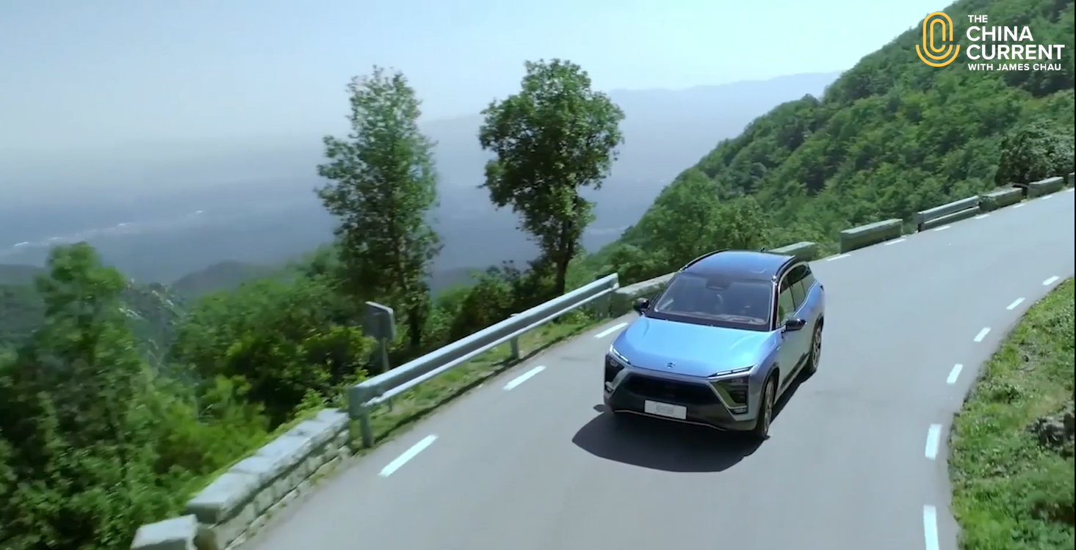 | Answer: ______
b. | 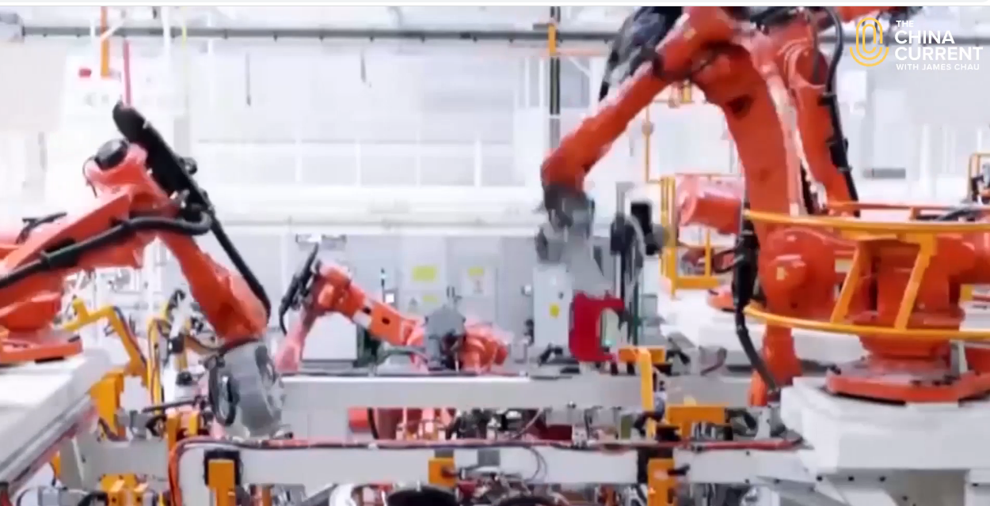 | Answer: ______
c. | 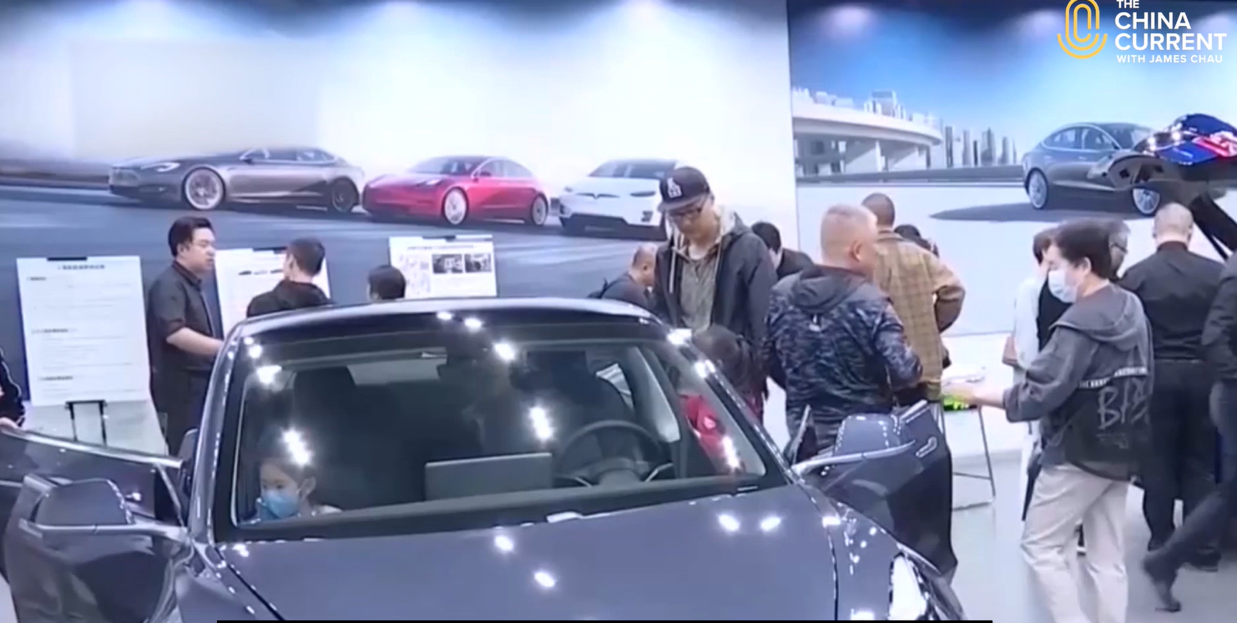 | Answer: ______

- What do you think this video is about?
__________________________________________________________________________
__________________________________________________________________________
__________________________________________________________________________
- Video-viewing activity – Electric Vehicles You’ll Want to Know About
Watch the video from The China Current and answer the following questions.

Video: Electric Vehicles You’ll Want to Know About
https://chinacurrent.com/story/23436/electric-vehicles-youll-want-to-know-about

- At the beginning of the video, the presenter says, “Demand for electric vehicles is surging.” Which of the following has a similar meaning to “surging”?
A. increasing slowly
B. increasing gradually
C. increasing rapidly
D. staying the same

- Decide whether the following statements are True (T), False (F) or Not Given (NG).
 | Statements | T | F | NG
a. | The EV market is developing fast in China.
b. | Lithium batteries are safer than solid-state batteries.
c. | NIO, Li Xiang and Xiaopeng will produce more models of EVs.

- According to the video, why are EVs getting more and more popular? Give two reasons.
- ______________________________________________________________________
______________________________________________________________________
- ______________________________________________________________________
______________________________________________________________________

- What is the purpose of the video?
A. To discuss the disadvantages of conventional vehicles
B. To entertain readers with interesting facts about car industry in China
C. To analyse the sales of EVs in China
D. To talk about the development of the EV industry in China

- Language Focus
- The infographic below summarises the ideas from the video. Fill in each blank with ONE word. You may use words from the video or your own words. Make sure your answers are grammatically correct.
ELECTRIC VEHICLES
Current market of EVs
While there is a rising demand for electric vehicles in both China and the United States, the EV market in China grows at a (a)__________ pace than in the United States.
Battery technology
- Unlike lithium cell batteries that are known for combustible hazards, engineers in China are developing a (b)__________ alternative – solid-state batteries.
- Solid-state batteries are (c)__________ likely to combust and require (d)__________ charging time.
Future of EVs
The trend in China supports the development of green tech and research to bring safer and
(e)__________ affordable EVs to the public. It is expected that the production capacity for EVs will double in China in 10 years and more products will enter the market.
- Some parts of the infographic have been highlighted. Match the items to the functions below. The first one has been done for you as an example.
Functions | Words from the infographic
- Comparing qualities of two/more items | (e.g.) safer, more
- Presenting similarities
- Presenting differences
Part 3 – Reading and Making Comparison
Read the fact sheet below to learn the strategies adopted in the Mainland and Hong Kong to promote EVs.
Fact Sheet on Strategies to Promote EVs
 | The Mainland | Hong Kong
Tax benefits | - Exemption from purchase tax was introduced in 2014 to boost EV sales.  - The policy of tax exemption has been extended three times up to 2023. | - First Registration Tax concessions are provided for e-private cars.  - Exemption from First Registration Tax and deduction of profits tax are provided for e-commercial vehicles.  - The policy of tax concessions has been extended to 2024.
Provision of government subsidies to the EV sector | - Government subsidies for EV manufacturers were introduced in 2009 to encourage EV development, making China the largest market for EVs since 2015. They came to an end in 2022 when the EV sector had become self-sustaining. | - Government subsidies are provided for research and development of green transport technologies.
Improvement of charging infrastructure | - China has the world’s largest charging network. Further expansion of the charging infrastructure is underway.  - The Government supports the exploration of battery swapping to further reduce the charging time. | - Subsidies are provided for private residential buildings to install charging infrastructure.  - More EV chargers are added at government car parks.  - The Government is exploring the feasibility of converting petrol and LPG filling stations to EV charging stations to build a territory-wide quick charging network.
Others | - Extra licence plates are issued for EVs.  - EVs are exempted from ban-days when the use of gasoline cars is restricted in big cities to reduce air pollution. | - The Government will ban the new registration of fossil fuel-powered private cars, including hybrid vehicles, by 2035.

Reference:
Environment Bureau (2021). Hong Kong Roadmap on Popularisation of Electric Vehicles. Retrieved from: https://www.eeb.gov.hk/sites/default/files/pdf/EV_roadmap_eng.pdf
Li, F. (2023). End of Subsidies Won’t Put Brakes on 2023 EV Sales as Demand Revved up. Retrieved 20 February, 2023, from chinadaily.com.cn.
The State Council of the People’s Republic of China (2022). Further Policy Support to Shore up NEVs. Retrieved 18 January, 2023, from English.gov.cn.
The State Council of the People’s Republic of China (2022). Ministry Set to Stabilize Price Hikes Affecting Auto Industry. Retrieved 18 January, 2023, from English.gov.cn.

- Venn diagrams are useful for organising information for comparing and contrasting. Extract relevant information from the fact sheet on P.8 to complete the Venn diagram to show similar and different measures taken by the Mainland and Hong Kong to promote EVs. With reference to the examples given, write two more points for each part of the Venn diagram.
Hong Kong
The Mainland
Both
- (e.g.) Provided subsidies which ended in 2022 as the EV sector had become self-sustaining

- (e.g.) Continue to provide subsidies for research and development of green transport technologies

- (e.g.) Provide(d) subsidies to the EV sector to facilitate its development

- Make two sentences with information from the fact sheet/Venn diagram and the expressions below to describe the similar strategies adopted in the Mainland and Hong Kong.

both, also, too, like, similar to, likewise, similarly

(E.g.) Similar to the Mainland, government subsidies are provided to the EV sector to facilitate the development of EVs in Hong Kong.
- __________________________________________________________________________
__________________________________________________________________________
- __________________________________________________________________________
__________________________________________________________________________

- Complete the sentences with the expressions below to show the different strategies adopted in the Mainland and Hong Kong to promote EVs.
Transition words followed by a clause | Transition words followed by a noun/noun phrase
- but/however,  - while/whereas  - on the contrary/in contrast | - unlike  - different from  - instead of

- Both the Mainland and Hong Kong governments subsidised the EV sector to facilitate its development. ____________, the Mainland Government withdrew its subsidies for EV manufacturers in 2022, seeing that the EV sector had become self-sustaining.
- ____________ the Mainland, which encourages drivers to use EVs by issuing extra licence plates and exempting EVs from ban-days in big cities, Hong Kong will ban the new registration of fossil fuel-powered private cars, including hybrid vehicles, by 2035 to make drivers switch to EVs.
- Make a sentence with information from the fact sheet/Venn diagram and the expressions above to compare the work done on improving EV charging infrastructure in the Mainland and Hong Kong.
On improving EV charging infrastructure, ________________________________________
__________________________________________________________________________
__________________________________________________________________________
__________________________________________________________________________.

Part 4 – Writing
Situation
To heighten students’ awareness of ecological security, the Government is organising a writing competition to further promote the use of electric vehicles (EVs) in Hong Kong.

Writing Competition

Theme: How to promote electric vehicles in Hong Kong

Let’s steer the wheel towards
a greener future
All S4 to S6 students
are welcome!

Submit your entry to evhk@es.gov.hk by 30 Apr 20XX.

You have recently done some research on the latest developments of EVs in the Mainland and Hong Kong and are going to write an article of about 400 words to join the competition.

Task
In your article, you would like to:
- Explain the importance of ecological security and how the use of EVs can help safeguard it (Part 1)
- Present the current developments of EVs in Hong Kong in comparison with those in the Mainland and what Hong Kong can learn from the Mainland’s experience (Parts 2 & 3)
- Suggest what the Government can do to further promote the use of EVs

Give your article a title.

Language Support
- Giving suggestions
- … can/may/should … (verb + noun/noun phrase)
e.g. To enlarge the public charging network, the government should allocate more resources
for installing EV chargers at government car parks.

- … (noun/noun phrase) is/are encouraged/recommended/advised to … (verb + noun/noun phrase)
e.g. The government is recommended to regulate carbon emissions as soon as possible to safeguard ecological security.

- It is advisable/important/necessary/essential for … (noun/noun phrase) to … (verb + noun/noun phrase)
e.g. It is essential for the government to ban fossil fuel-powered private cars in the near future.

- Talking about current trends/developments
- present continuous tense
e.g. Demand for electric vehicles is surging, particularly in China, where the EV market is increasing at a faster pace than in the United States.
e.g. Engineers in China are beginning to develop solid-state batteries to replace the current lithium cell batteries…

- Presenting differences
- while/whereas … (clause)
e.g. The Hong Kong Government is exploring the feasibility of converting petrol and LPG filling stations to EV charging stations while the Mainland Government is exploring the possibility of battery swapping to further reduce the EV charging time.

- However/Conversely/In contrast/On the contrary, … (clause)
e.g. Lithium batteries are known to be combustible hazards. In contrast, solid-state batteries would greatly reduce these risks.

- Unlike/Different from … (noun/noun phrase)
e.g. Unlike the EVs today, those produced in the future will be safer, more affordable and more environmentally-friendly.

- Presenting similarities
- both/all/too/also
e.g. The EV markets in both the Mainland and Hong Kong are expanding.

- Like/Similar to … (noun/noun phrase)
e.g. Similar to the rest of the world, there is a surging demand for electric vehicles in the Mainland and Hong Kong.

- Likewise/Similarly, … (clause)
e.g. EV producers in the Mainland will take advantage of the new technology to produce safer and more affordable electric vehicles. Likewise, EV makers worldwide will keep inventing and creating new models which are cleaner and more environmentally-friendly.

__________________________________________

